


COMMISSION ON THE SUSTAINABIITY OF RURAL SYSTEMS - IGU
Commission on the Sustainability of Rural Systems

Commission sur le Développement Durable et les Systèmes Ruraux

21st Annual Colloquium
Commission on the Sustainability of Rural Systems
International Geographical Union

Nagoya University, Japan, 29 July-4 August 2013

Colloquium Theme
and
Call for Papers

Globalization and New Challenges of Agricultural and Rural Systems

Please send initial queries to: igu.csrs2013@gmail.com
Official website: http://www.csrs2013.ccsv.okayama-u.ac.jp

Organising Committee:
Professor Doo-Chul Kim (Chair, Okayama University)
Professor Makoto Takahashi (Nagoya University)
Professor Takahiro Ito (Aichi University of Education)
Professor Katsuyuki Takenaka (Aichi Prefectural University)
Professor Satoshi Yokoyama (Nagoya University)

Dr. Takehiro Morimoto (University of Tsukuba)
Dr. Katsuki Umeda (Chiba University)
Dr. Daichi Kohmoto (Kobe Shukugawa Gakuin University)
Dr. Takuya Hayashi (Gifu University)
Mr. Yasuo Ichikawa (University of Tsukuba)

Globalization and New Challenges of Agricultural and Rural Systems
The title of the 21st Annual Colloquium of the International Geographical Union Commission on the Sustainability of Rural Systems (CSRS) arises from broad concerns of the Commission and from the opportunity that Japan offers to reflect on particular aspects of these concerns. Papers are invited under seven broad themes, outlined below.

COLLOQUIUM THEMES
The Colloquium will address a number of key themes of current concern in rural areas under the broad heading of Globalization and New Challenges of Agricultural and Rural Systems. Abstracts are invited for papers that address the following themes and sub-themes, broadly defined, from theoretical perspectives and that document processes of change in particular geographical contexts:

1. The social construction and analysis of 'rural sustainability'
2. Governance and rural development: progress and prospects
3. Rural society, population and settlement under conditions of economic and social change
4. Sustainability and the rural business enterprise
5. Heritage, tourism and environment: challenges and opportunities
6. Sustainability in the interaction between rural and urban systems
7. Land use, agriculture and food: issues of local sustainability in a global context

VENUE
Graduate School of Environmental Studies, Nagoya University, JAPAN
http://www.env.nagoya-u.ac.jp/en/index.html
(campus map) http://www.env.nagoya-u.ac.jp/en/contact/map.html

Conference will be held at Lecture Hall on the ground floor of the Environmental Studies building at Higashiyama campus of Nagoya University. The building is located at D2 block of the campus map below.
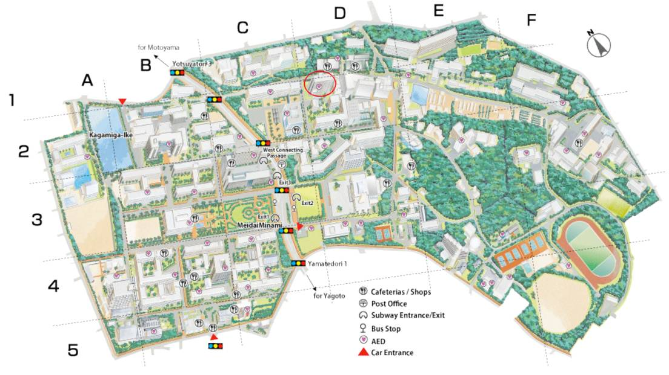
SCHEDULE
29th July: Arrive in Nagoya, Registration and Welcome Party
30th July: Official Opening and Addresses by Co-Chairs of the Commission, Paper session
31st July: One day Excursion to Atsumi Peninsula
1st August: Paper session, Banquet
2nd - 4th August: Three full day fieldtrip

REGISTRATION FEE
Early Full Registration Fee (by May 31) 65,000 JPY
Late Full Registration Fee (after June 1) 73,000 JPY
Accompanying person Full Registration Fee 60,000 JPY
Participant who does not join to fieldtrip from 2nd to 4th Aug. : 25,000 JPY
Accompanying person who does not join to fieldtrip from 2nd to 4th Aug : 20,000 JPY

Method of payment: by credit card
* Participants should fill in the Payment Form (payment.doc) and send it to our official travel agency (Meitetsu World Travel Inc.) via fax or email (igu-csrs@mwt.co.jp). Upon receipt, they will send you a confirmation e-mail. The person in charge is Mr. Yoshiyuki Shimada.
* Important! The Payment Form is protected by a security code. To open the file, you should enter "igu-csrs2013", in small letters without quotes.
* Those who have difficulties to pay by credit card should contact to the official travel agency. (igu-csrs@mwt.co.jp Mr. Yoshiyuki Shimada)
Please remember that the best way for you to reduce costs is paying by credit card.
Costs covered by the Registration Fee:
* The Registration Fee for all participants covers the following:
1) Colloquium: Conference Handbook with abstracts and field site information; teas and coffees during the Conference; Welcome Party on 29th July, Banquet on 2nd August; one copy of the published proceedings for each author in due course.
2) Field visit on the 31st July: Coach hire costs; lunch; entry fees to tourism sites.
3) Field trip during 2nd-4th Aug (only for full registration participants): Coach hire costs; entry fees to tourism sites; two night accommodations with breakfast; lunch and dinner on 2nd and 3rd August; lunch on 4th August.
* The Registration Fee for accompanying person covers the all in above except the following: Conference Handbook with abstracts and field site information; one copy of the published proceedings for each author in due course.

* Important! The Registration Fee does NOT include accommodation costs in Nagoya. For more information, please see the next section.

ACCOMMODATION (from the night of 29th July to 1st August)
* Participants can book and pay the accommodation in Nagoya, from 29th July to 1st August, through the official travel agency. Just check what you need in the Payment Form. You will be charged for it together with the Registration Fee. You have the following two options to choose from:

Meitestu New Grand Hotel
Single 9,500JPY, Twin 16,000JPY / night *Breakfast is not included.
http://www.meitetsu-ngh.jp/en/

Chisun Inn Nagoya
Single 7,000JPY, Twin 13,000JPY / night *Breakfast is not included.
http://www.solarehotels.com/english/chisun/inn-nagoya/guestroom/detail.html?nid=TKI_CINag_e
* You can also book your accommodation in Nagoya by yourself. The city has a wide range of accommodation available.
* The coach for field visits will depart from Meitestu New Grand Hotel both on 31st July and 2nd Aug. Also, the banquet on 1st Aug. will take place at the above-mentioned hotel.
* For information on Nagoya Metro system;
http://www.kotsu.city.nagoya.jp/english/english_sub.html
Abstracts

Authors are invited to submit abstracts under the themes given above but are not limited to those themes only. Abstracts will be sent for review and participants will be informed by 31st March whether an abstract has been accepted. Inclusion of an abstract in the Colloquium Handbook is dependent on receipt of the Registration Fee by 31st May, after which a late fee penalty 8,000JPY will apply.
Abstracts of no more than 450 words in length should be submitted to the local organizer (igu.csrs2013@gmail.com) as an attached file by 28th February, using the following format:
Language: English
Font: Times New Roman 12pt
Spacing: single spacing
Alignment: all text should be left aligned
Title of paper: Upper case
Title and name of author/s: in bold; title, first name followed by surname in capitals; followed by the institutional address in plain text; and email address in italics
Corresponding author: if different from the first author, write in brackets after the name
Institutional affiliation: the institutional affiliation of each author should be given
Endnotes or sub scripts: should not be used
Please note: faxed abstracts will not be accepted

Important CSRS dates in 2013

28 February | Registration for the Colloquium and deadline for submission of abstracts. Please submit abstracts to the local organizer (igu.csrs2013@gmail.com), following the format provided.
31 March | Confirmation of abstract acceptance
31 May | Deadline for payment of Early Registration Fee. A late submission fee of an additional 8,000JPY will apply thereafter. Please send the Payment Form to the official travel agency (igu-csrs@mwt.co.jp).
15 June | Deadline for inclusion of Abstract in the Colloquium Handbook. Please submit abstracts to the local organizer (igu.csrs2013@gmail.com), following the format provided.
30 June | Deadline for payment of Late Registration Fee
29 July | Arrival in Nagoya for the Colloquium
TRAVEL
Nagoya is well served by air, train and bus transport. The conference is held at Higashiyama Campus of Nagoya University in Nagoya City. Higashiyama Campus is just off the subway exit of Nagoya Daigaku Sta. (Nagoya Daigaku stands for Nagoya University in Japanese.)

From Central Japan International Airport to Nagoya Daigaku Sta.:
The most convenient route to Nagoya City from abroad is the direct arrival at Central Japan International Airport "Centrair". Take the Meitetsu Line from the airport terminal to Kanayama Sta. (30 min), and then transfer to the Subway Meijyo Line (counterclockwise) and get off at Nagoya Daigaku Sta. (21 min).

From Other Airport to Nagoya Daigaku Sta.:
When you arrive at international airports of Tokyo or Osaka, first you should reach Nagoya Station by railways and then transfer to Subway as follows.

From Narita International Airport to Nagoya Station: Take Narita Express or Airport Rapid to Tokyo Sta. (60 min), and then transfer to Tokaido Shinkansen (bullet train) to Nagoya Sta. (100 min by NOZOMI super express).

From Tokyo International Airport to Nagoya Station: Take Keihin Kyuko Line’s Airport Rapid Train to Shinagawa Sta. and then transfer to Tokaido Shinkansen for Nagoya Sta. (95 min by NOZOMI super express).

From Kansai International Airport to Nagoya Station: Take JR Kansai Airport Limited Express HARUKA to Shin-Osaka Sta. (52 min), and then transfer to Shinkansen to Nagoya Sta. (52 min by NOZOMI super express).

From Nagoya Station to Nagoya University: Take the Subway Higashiyama Line bound for Fujigaoka Sta., then transfer at Motoyama Sta. to the Subway Meijyo Line (clockwise) and get off at Nagoya Daigaku Sta. (21 min).

Details are also available on the Colloquium web site:
(http://www.csrs2013.ccsv.okayama-u.ac.jp).

FIELD VISITS
The field visits are integrated in the scientific programme, involving one day and three full day excursions to locations in central Japan. They will provide opportunities to view a number of different landscapes, examples of challenges to the sustainability of rural systems and responsive strategies in operation. We shall meet with agency personnel, local residents and farmers. Colleagues who have researched the areas and issues in question will provide commentary also.
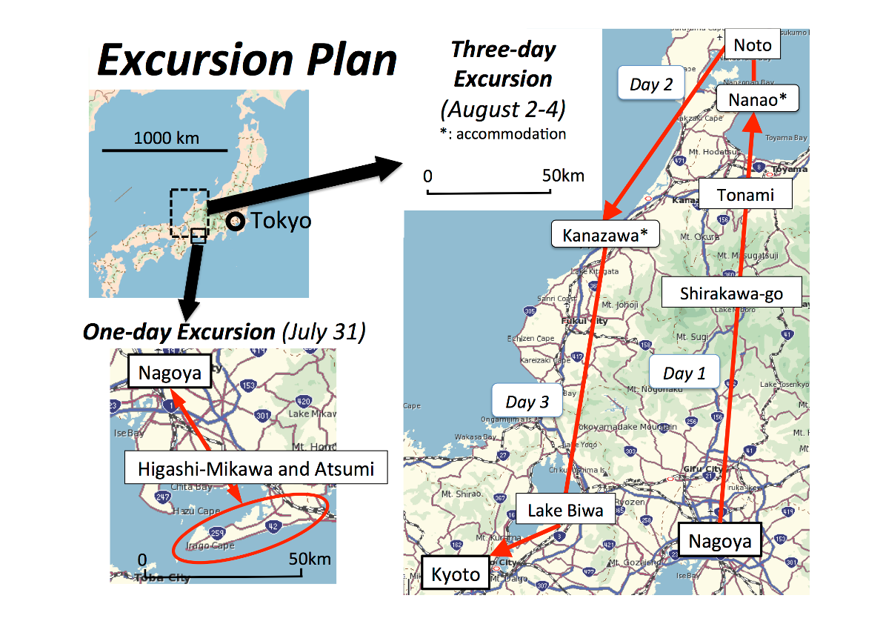
ONE-DAY EXCURSION
31st July : Atsumi Peninsula
Sustainable or Neo-productivist Agricultural Development?

The Atsumi Peninsula, located in the southeast part of Aichi Prefecture, is a leading agricultural area for vegetable and flower production in Japan. During the rapid economic growth of Japan, the traditional agricultural activities of the Atsumi were dramatically changed from Factory Distribution System of Chrysanthemums the upland field farming of sweet potato,
wheat and barley to vegetable and flower horticulture as a result of the construction of Toyokawa irrigation canal. Farmers have continuously adopted new techniques on vegetable and flower cultivation to increase their farm productivity and to withstand the interregional competitions. The Atsumi has evolved a mega producing area of cabbage, melon, and Chrysanthemums since 1980's. The agricultural cooperative of Atsumi has played an important role in the formation of mega producing area of their products by the construction of automatic distribution factories to encourage growers to expand their production and by marketing to Tokyo, Osaka and Nagoya urban regions. The Atsumi has kept one of leading position of the Japanese productivist agriculture region. However, vegetable growers have obtained the certification on environmental-friendly farming by the agricultural ministry of Japan since 2000's. This eco-farming trends implicate the future of sustainable development of the Atsumi agriculture. The excursion will provide opportunities for discussing the issues with regard to the productivism and sustainable agricultural development of Japan.

THREE-DAYS EXCURSION

2nd August: Shirakawa-go & Tonami dispersed settlement (sankyo-son)
Rural tourism relives remote mountain villages?
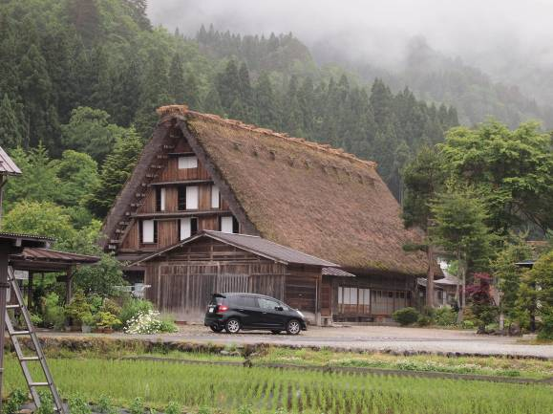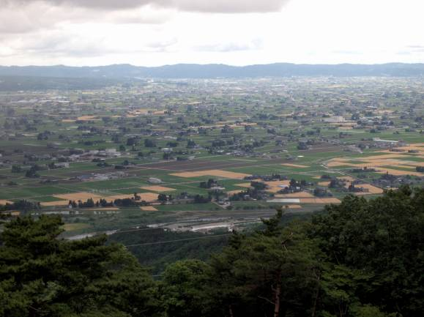
Gassho-zukuri village in Shirakawa-go Dispersed settlement on the Tonami plain

The central highland of Japan includes one of the most important rural landscapes on mountain villages. Gassho-zukuri village in Shirakawa-go is listed as a site of the World Heritage in 1995. Gassho-zukuri is a house built of wooden beams combined to form a steep thatched roof that resembles two hands together. It is the ideal style to slip snow on roof, as the cumulative amount of snowfall reaches 10m in winter. The houses stand in a certain direction to adjust the amount of sun in order to keep the room cool in the summer and warm in the winter. In the afternoon, we will visit the dispersed settlement (sankyo-son) on the Tonami plain, the reprehensive rice farming area in Japan. Farmers’ house surrounded by residential trees (Yashiki-rin) are scattered among rice paddies. The unique farming and living style utilizing rich nature is still alive in the dispersed settlement.
(Overnight in Nanao City, Ishikawa Prefecture)

3rd August : Noto Peninsula designated as a site of GIAHS
Japanese cultural landscape and new challenges in remote rural areas
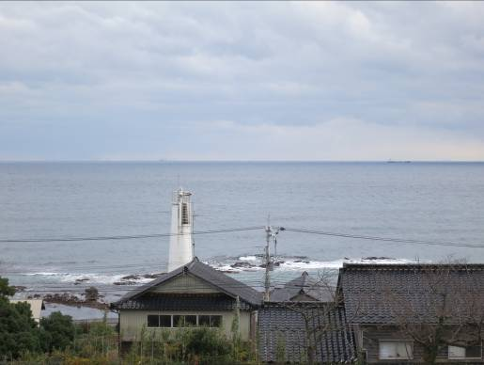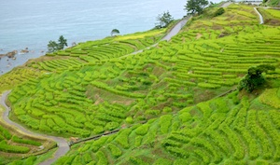
Site of Globally Important Agricultural Heritage Systems and Terraced Rice Fields

Noto Peninsula was designated as a site of Globally Important Agricultural Heritage Systems (GIAHS) by FAO in June 2011, and this was the first case along with Sado Island in Japan. The focal points of Noto Peninsula are its “Satoyama” and “Satoumi”. “Satoyama” is a Japanese term which means socio-ecological production landscapes that combine small scale agriculture and forest, and “Satoumi” means marine-coastal ecosystems. They have been shaped over the hundreds of years by the interaction between people with nature, but most of them are changing to abandoned landscapes.
In the morning of the second day, we will visit Mii-machi, Wajima City, an ideal place to find the traditional roles of “Satoyama” in Japanese rural life. We will walk around a small traditional rural village with local residents talking about traditional rural life and new challenges in Japan. We can also have a casual workshop with “Maruyama-gumi”, an volunteer group, who has successfully coordinated educational and conservation activities by utilizing “Satoyama” with local residents. (http://maruyamagumi.blog102.fc2.com/ )
After lunch with the traditional local food, we will move to Shiroyone Senmaida (Terraced Rice Fields) where more than two thousand rice fields ascend a steep slope in a terrace formation. The size of a field is approximately three “tatamis” (2.7m x 5.4m) on average, and since machines are unable to enter there, rice planting and cutting is performed by manual labour. We can discuss with local residents why and how they have reclaimed and conserved such a steep slope. (Overnight in Kanazawa City, Ishikawa Prefecture)
4th August: Lake Biwa and its Watershed
Rich history and environmental friendly agriculture
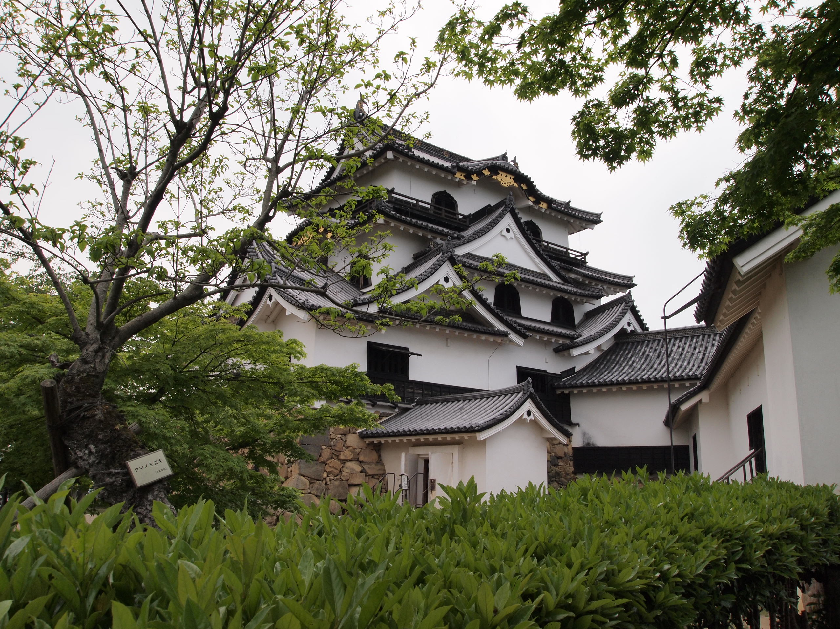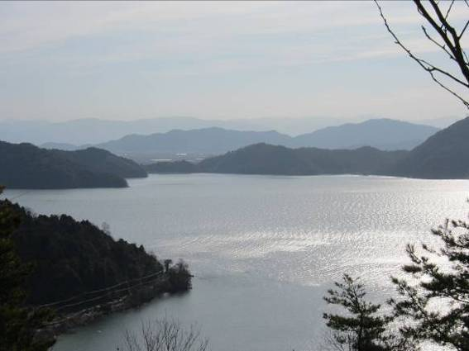
Hikone Castle Lake Biwa

Lake Biwa is the largest freshwater lake in Japan, located in Shiga Prefecture close to the Kyoto and Osaka conurbation of the second largest in Japan, providing drinking water for approximately 15 million people of the conurbation. We can see the landscape of small lowland villages and towns in the canal networks that are connected to the lake. In the period of the post-war economic growth, the region’s proximity to the conurbation brought about the rapid housing and industrial developments, causing severe environmental problems, including water pollution. To address such problems, in the early 1980s, the local people began to organize anti-pollution campaigns, and the local government enforced the legislation to prevent eutrophication regulating the household effluent and industrial waste. In 1993 the lake was designated as a Ramsar Wetland to protect its biodiversity. Recently, local governmental and non-governmental organizations take initiative in a variety of environmental practices at the grassroots level. Along with the above environmental issues, we will visit a large-scale agriculture area which was established by the reclamation of the lake. We can discuss with local farmers on agriculture and environmental issues.
Hikone Castle, standing in elegant profile against Lake Biwa, is regarded as one of four national heritage castles of Japan. Its three-layered chalk castle tower still maintains its noble and heroic appearance as a symbol of the city. We will stop at several key places of such environmental and historical practices in Shiga Prefecture before arriving the final destination, Kyoto International Conference Center. (*Kyoto IGU Congress from the 4th to 9th August.)

We look forward to welcoming colleagues to Nagoya in 2013!
http://www.csrs2013.ccsv.okayama-u.ac.jp

