
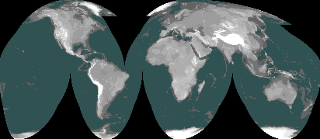

COMMISSION ON THE SUSTAINABIITY OF RURAL SYSTEMS - IGU
Globalization and New Challenges of Agricultural and Rural Systems
21st Annual Colloquium
Commission on the Sustainability of Rural Systems
International Geographical Union

Nagoya University, Japan, 29 July-4 August 2013
Systèmes Ruraux

REGISTRATION FORM

Family Name First Name/s

Title: Prof Dr Mr Ms

Gender male female

Affiliating organization

Mailing Address

City __________________________State ______________________________

Zip Code _____________________ Country _______________________________

Telephone __________________________ Fax

E-mail

I wish to present a paper; oral poster

Presentation Title:

Name(s) of author(s):

I will be attending the Kyoto IGU Congress: Yes No

Special Needs (Please let us know if you have special dietary or medical needs)
Health/Disability Needs ________________ Dietary Needs ______________________

Please return this form as an email attachment to the local organizer, igu.csrs2013@gmail.com before 31 January 2013.

