15.11.2016

Timo Huttula; Course on: Modeling in aquatic environment

Exercise 1.

We want to learn how an operational watershed model is used for hydrological forecast. We use Finnish WSFS-model for Lake Tuusulanjärvi. It is situated about 9 km NE from Helsinki Airport

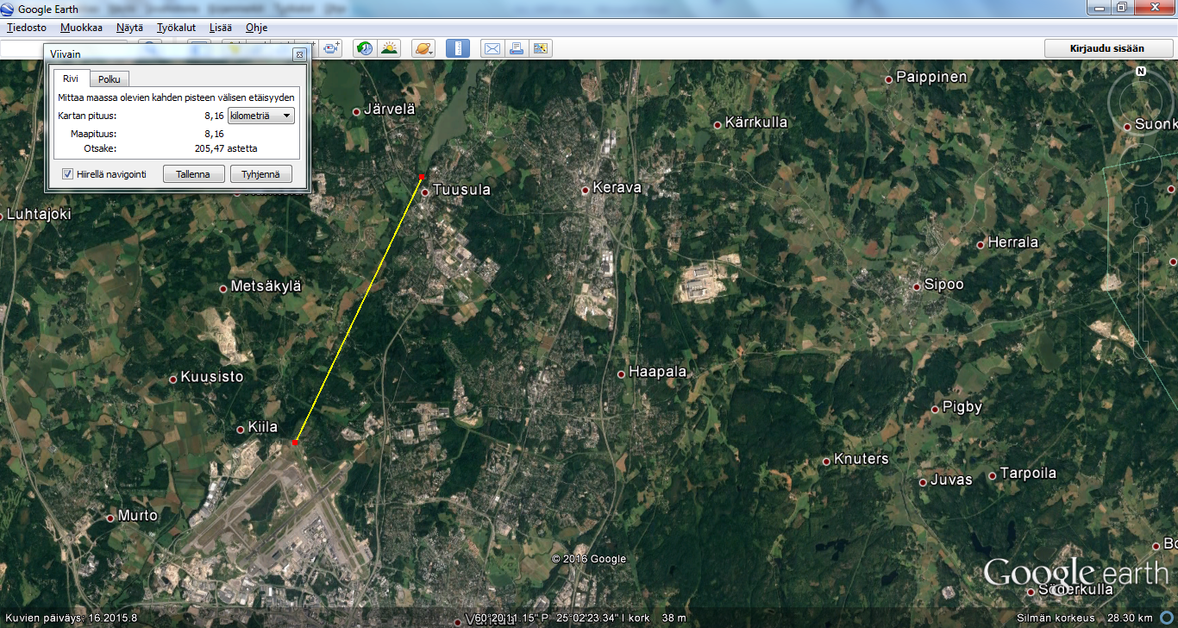

Our task is to know what is the situation of the lake waterlevel and water temperature and how they will be developed in near future. Also we discuss about the causal relationships between weather and hydrlogical variables.

Go to web-site <http://www.ymparisto.fi/en-US/Waters/Hydrological_situation_and_forecasts/Hydrological_forecasts_and_maps/Hydrological_forecasts_and_maps(26174)> You will see the main page of the of WSFS-products (automatic). Go down and you see as follows.

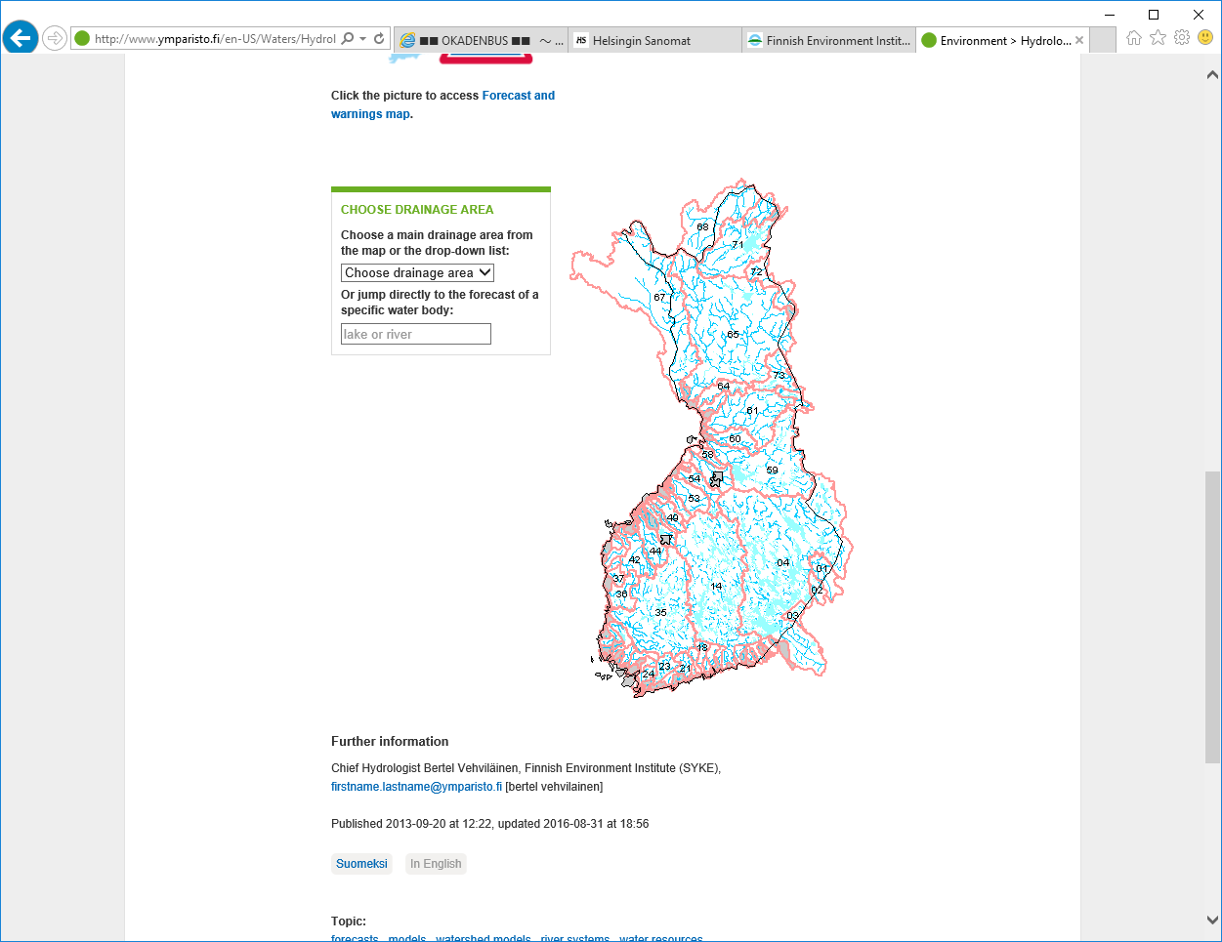

Select river basin 21 Vantaanjoki (as Tuusulanjärvi belongs to this watershed). You see thin light red colored lines. The show the subdivision of the watershed. You can move around the watershed and point different locations.

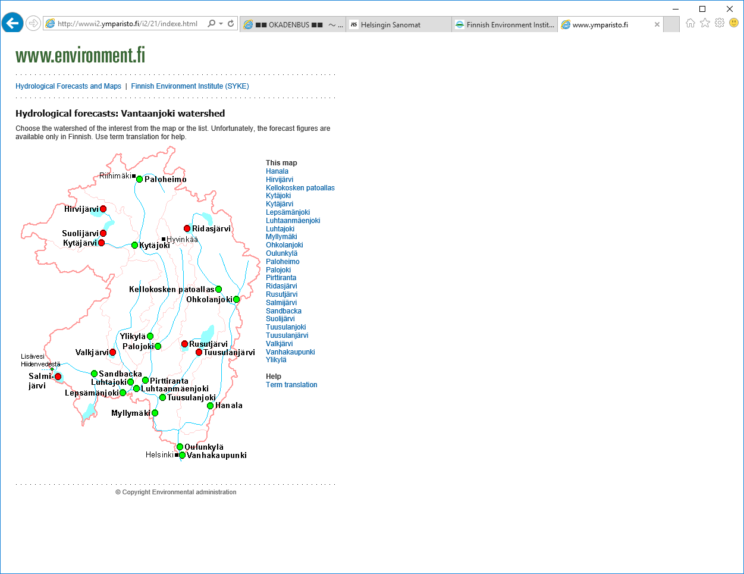

And put the pointer on the word ’Tuusulanjärvi’ for more detailed information about hydrology of this watershed. Following web site appears:

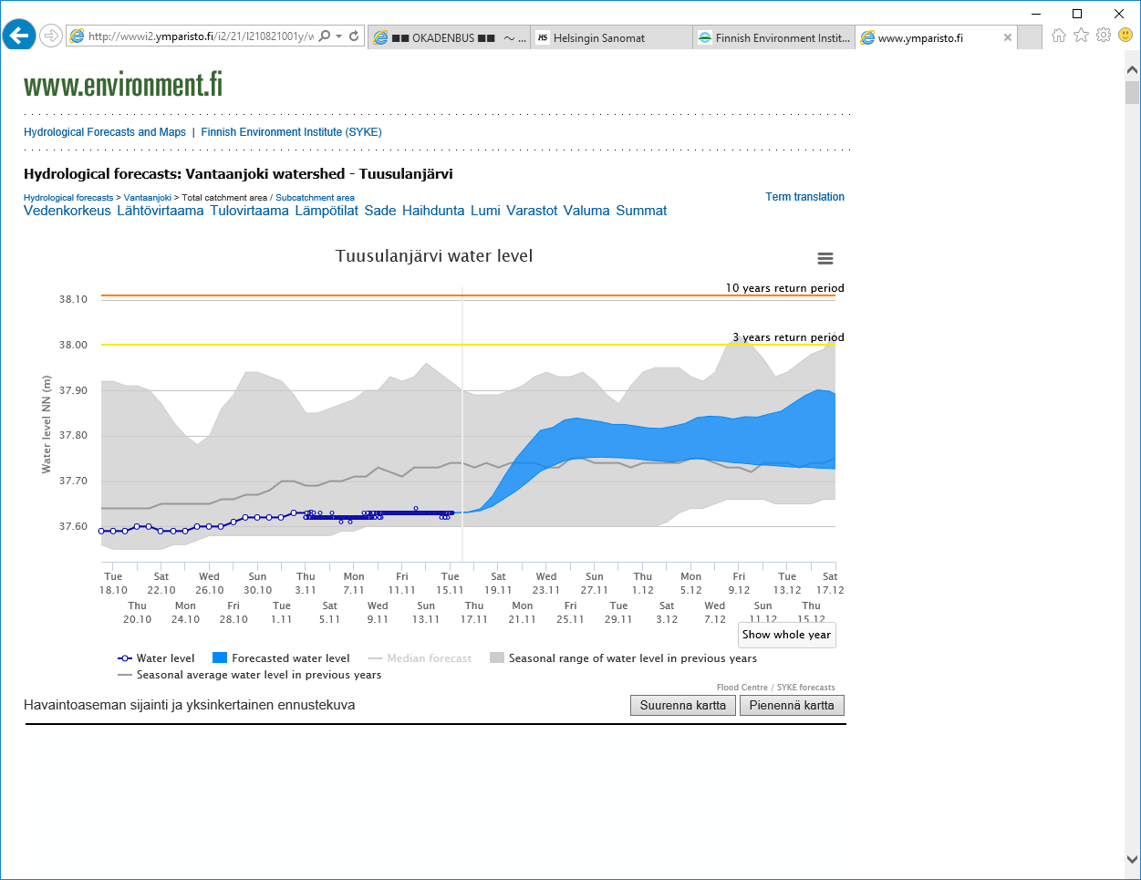

.

Note the link ‘Term translation’ on the right side of the page. It will open following page.

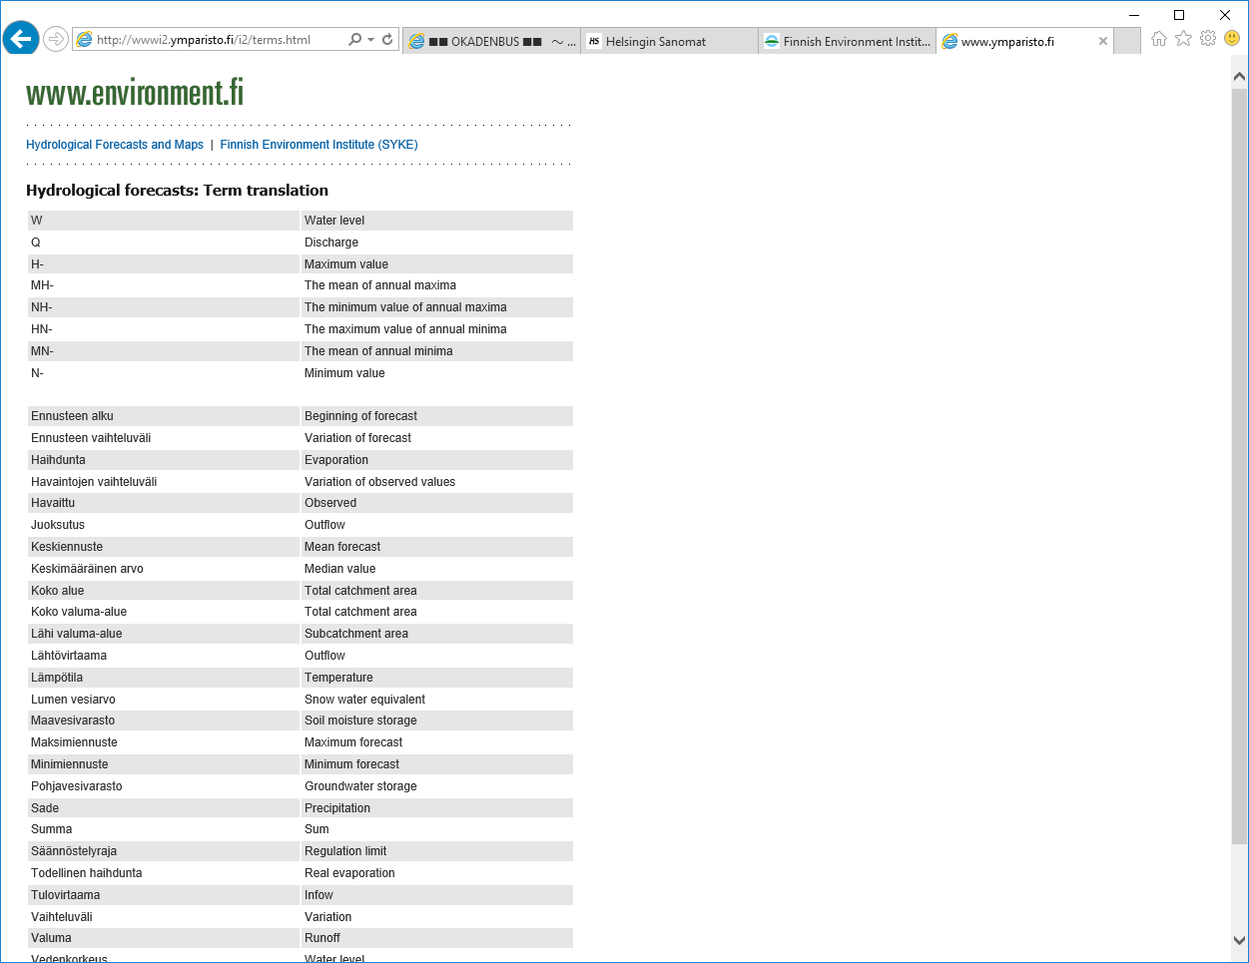

Questions for our discussion:

Q1: What is the present (on Nov. 16, 2016) water level in Lake Tuusulanjärvi?

Q2: When the water level will increase? How much in how many days?

Q3: What is the present water temperature in this lake?

Q4: What will happen for the water temperature in this lake during next seven days?

Q5: What is the reason for water level rise?

Q6: What is the reason for water temperature change?