15.11.2016

Timo Huttula; Course on: Modeling in aquatic environment

# Exercise 2.

In this exercise we will use one CSTR-model (LLR) for estimating target loads for the Lake Tuusulanjarvi, Finland. You use model through internet. The model uses actually three different options for target load calculation. This has to do that fact for very many lakes we do not have data. So, same parameter values have been derived from large number of Finnish lakes, European + North American lakes. The calculation shows

1. Results with lake specific data
2. Results using parameter values based on large number of Finnish lakes
3. Results using parameter values based on large number of European and North American lakes

In Finland we are lucky since we can use Vemala model for producing lake specific data. Now for Tuusulanjarvi watershed the nutrient (total phosphorus and nitrogen) as well as suspended (SS) loads have been calculated by WSFS-Vemala model for a period of 1991-2015 and also for years 2016-2050. So we can make some lake specific simulations about lake state development in future.

## LLR-sub model selection and basic data collection of the lake

Go with your browser (IE or Mozilla) to <http://llr.vyh.fi/cgi-bin/frontpage.cgi?kieli=ENG>

The main page of Lake Load Response (LLR) will be opened as below:

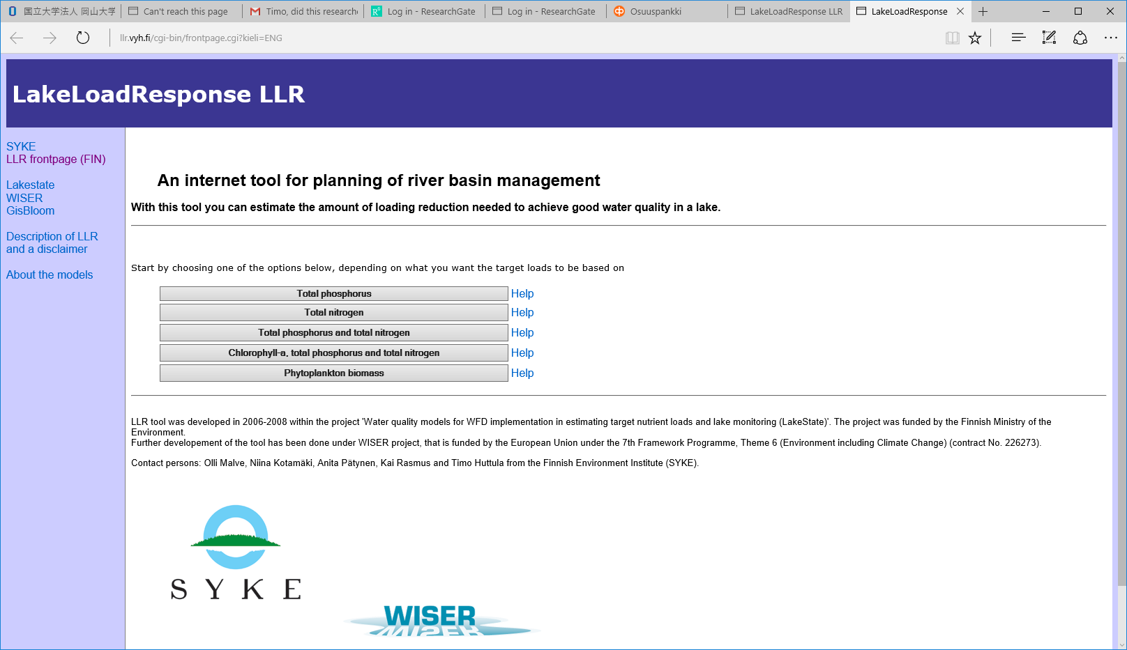

Choose option four from above (Cholophyll-a,....) by clicking the button. You will see:

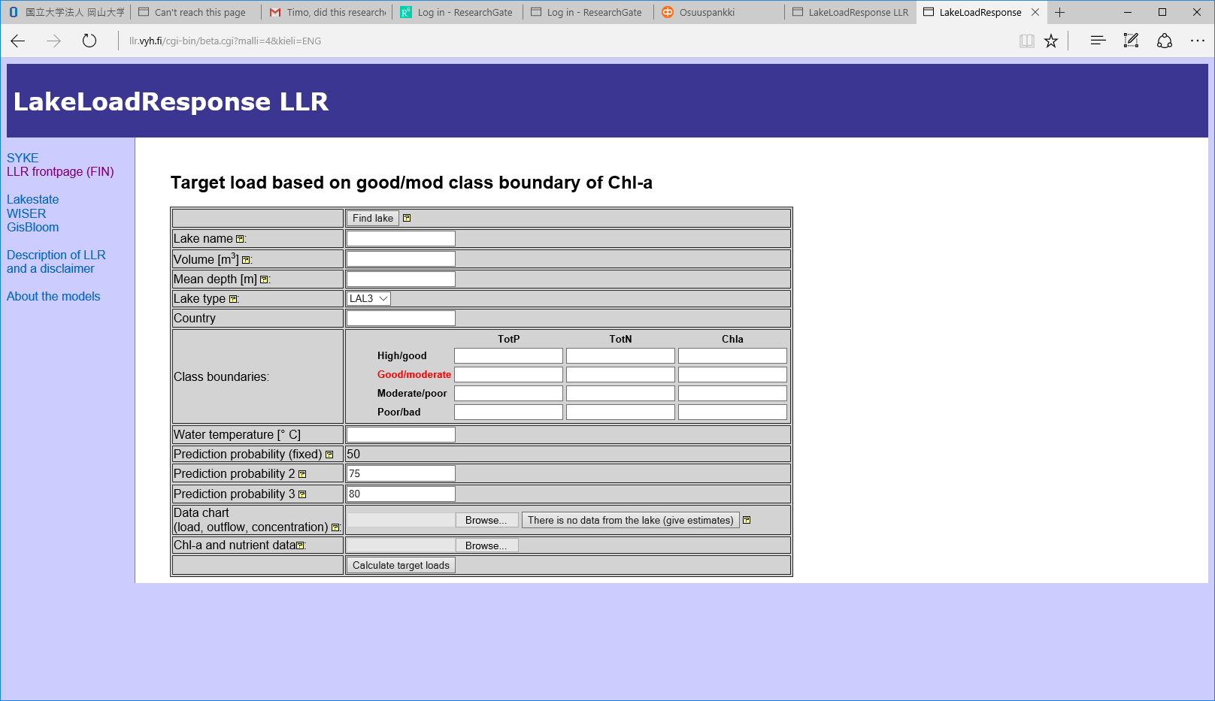

Now we choose lake and it’s basic data by clicking the button ’Find lake’. You will see a new screen like below. Enter first characters of the lake name lake ’Tuus’ as below.

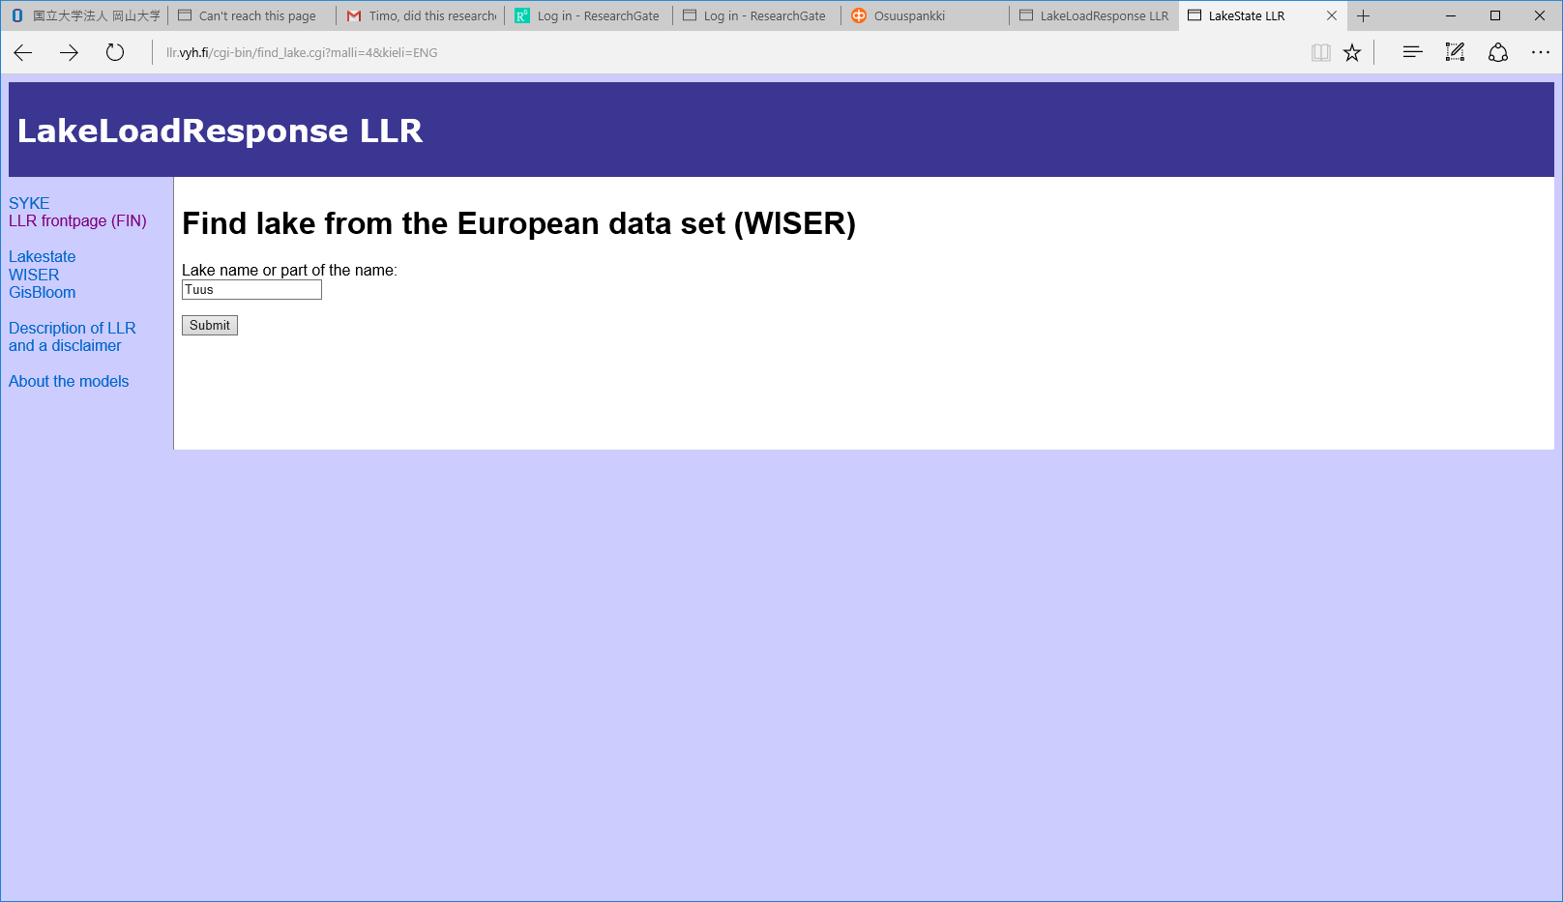

After that click the button ’Submit’. You will get the data of the lake on the screen as below:

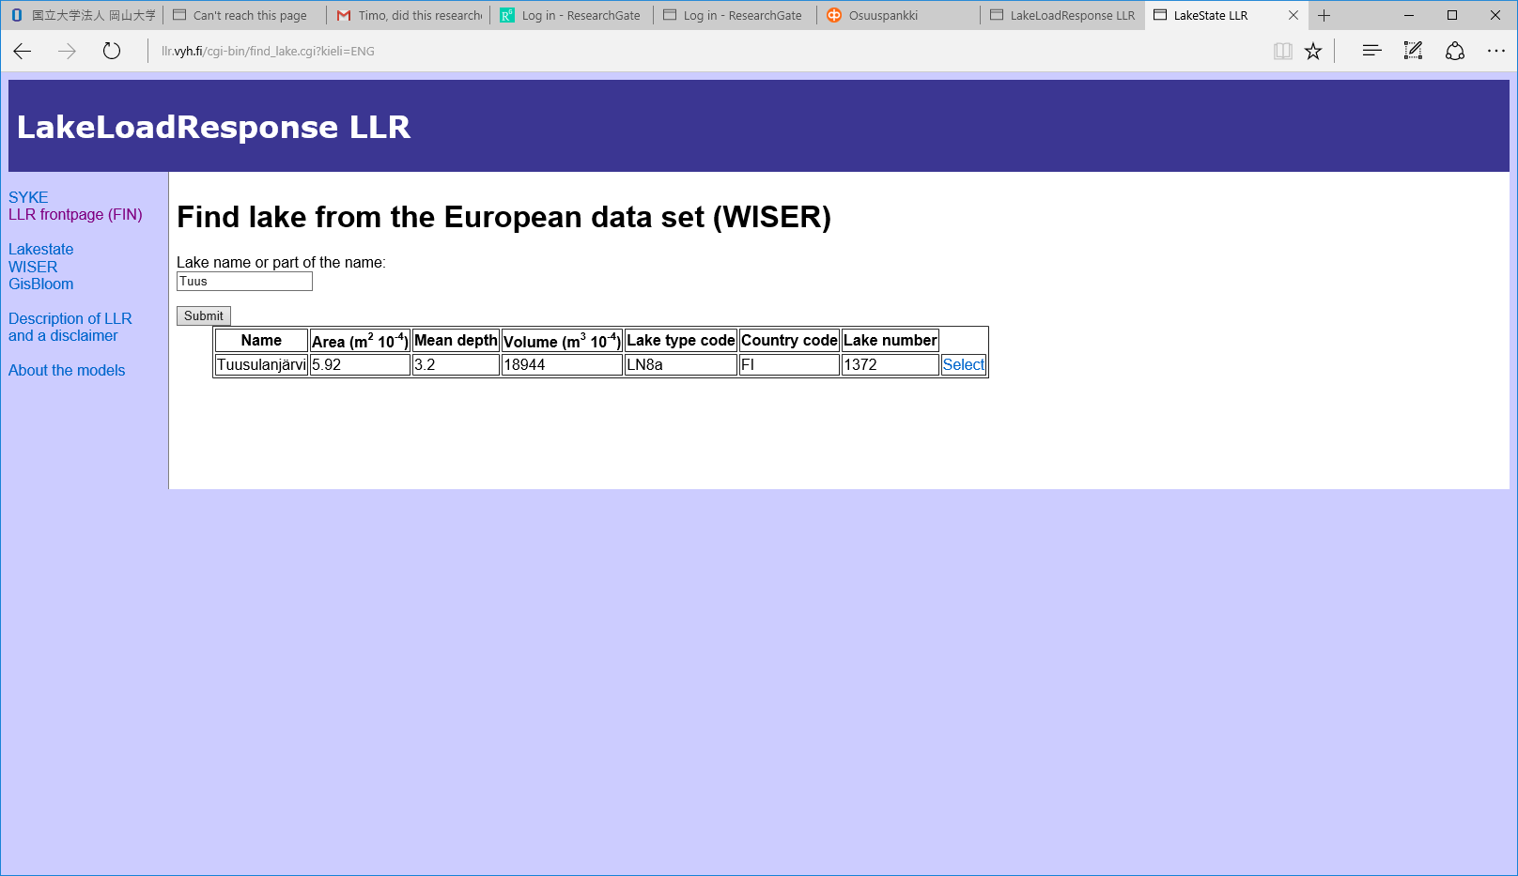

Click the ’Select’ link on the right and the data will be transfered to the model as below:

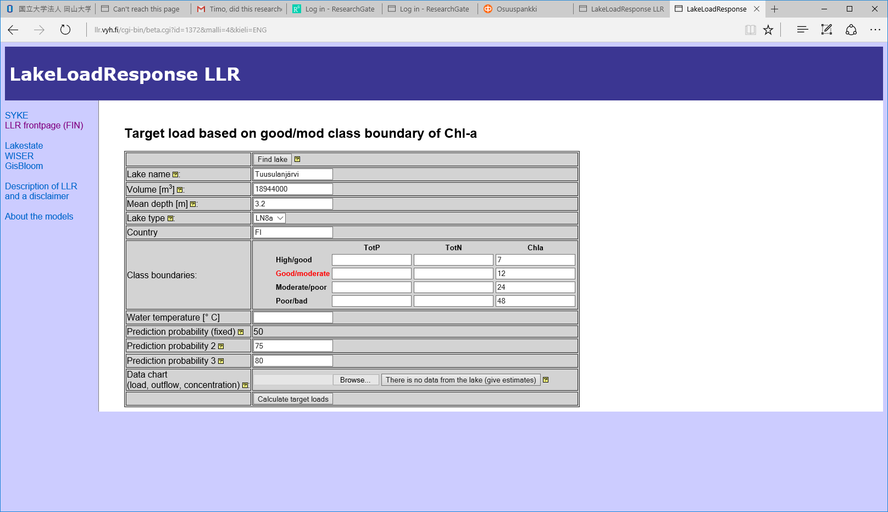

Now you can enter the water temperature. It is important for plankton growth. Cholorphyl-a content is describing the phyto plankton in this model. Use for temperature 18 Celcius and type it to corresponding box.

## Loading data arrangement

For connecting the file containing nutrient and as well as SS-loads to LLR-model. Some file editing has to be done. I give the example below. You don’t need to do this.

From Vemala we have got as out for Tuusulanjarvi watershed a file looking like this:



We have to organise it so that the columns are in right order as below.

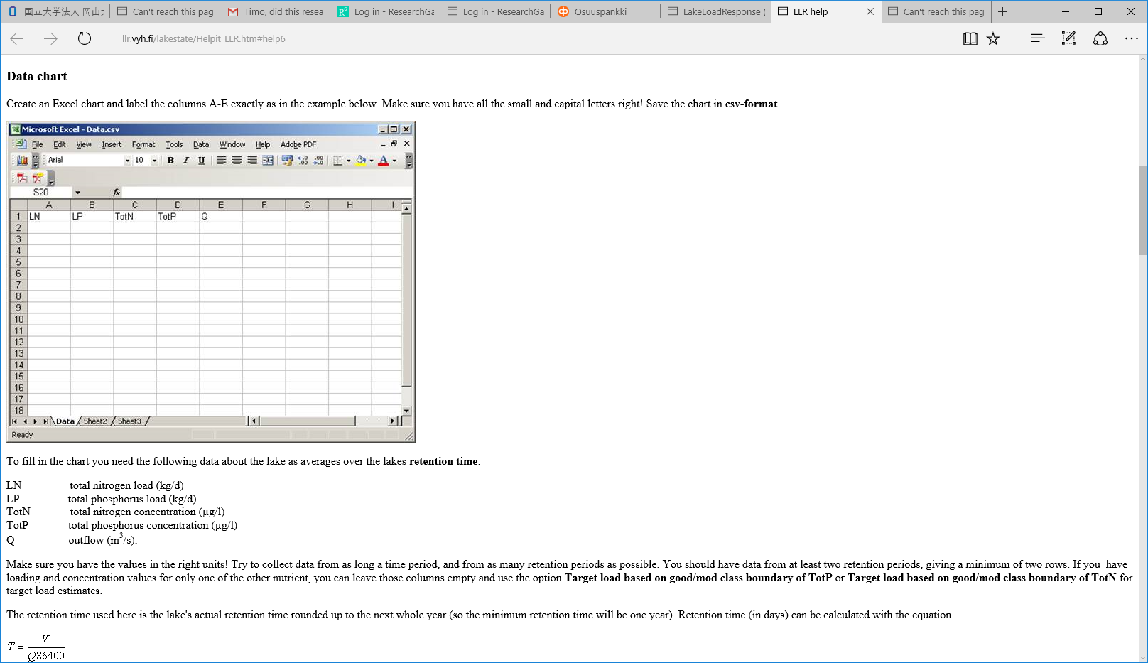

I have done this for you and now the input file ’ Tuusulanjarvi_LLR_input.csv ’. When we open (but please do not open it!!) it, it looks like:

|  |  |  |  |  |  |
| --- | --- | --- | --- | --- | --- |
| LN;LP;TotN;TotP;Q | |  |  |  |  |
| 236 | 44;9 | 15;1684 | 91;106 | 21;0 | 92 |
| 243 | 56;12 | 33;1450 | 67;98 | 82;0 | 88 |
| 342 | 47;16 | 16;1679 | 23;118 | 57;1 | 40 |
| 110 | 68;7 | 40;1266 | 53;93 | 81;0 | 63 |
| 147 | 40;11 | 45;1117 | 67;111 | 70;0 | 89 |
| 168 | 49;8 | 63;1194 | 59;97 | 23;1 | 9 |
| 232 | 60;28 | 03;1115 | 15;94 | 46;1 | 21 |
| 115 | 89;7 | 37;1368 | 89;116 | 44;0 | 66 |
| 260 | 55;20 | 05;1144 | 41;88 | 24;1 | 30 |
| 206 | 03;9 | 84;1138 | 93;94 | 27;1 | 7 |
| 282 | 74;16 | 03;1486 | 36;72 | 38;1 | 12 |
| 225 | 75;11 | 37;1229 | 82;95 | 77;0 | 83 |
| 139 | 45;7 | 78;966 | 36;76 | 69;0 | 78 |
| 156 | 71;4 | 47;896 | 36;65 | 45;0 | 49 |
| 277 | 53;20 | 19;1311 | 27;87 | 51;1 | 45 |
| 223 | 01;13 | 29;1151 | 46;92 | 72;1 | 17 |
| 205 | 21;16 | 03;1070 | 64;85 | 90;0 | 92 |
| 238 | 90;19 | 92;1548 | 67;100 | 42;1 | 5 |
| 244 | 38;21 | 86;1271 | 50;126 | 70;1 | 43 |
| 71 | 60;6 | 88;933 | 86;107 | 88;0 | 55 |

Use ’Browse’ button to select this file.

Now the screen should look like:

Now you are ready to start simulation. Push the button ’ ’ and run will start. It may take 5-10 min.

## Results

When the run has been completed following screen appears:

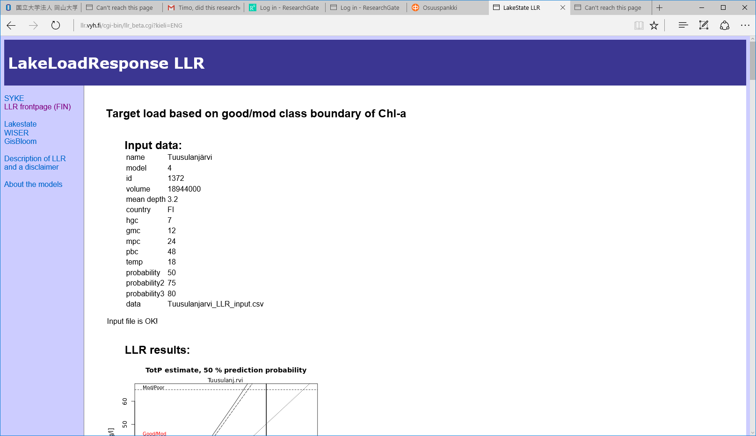

Scroll down and study the results both in figures and tables.

The tables are in such a form:

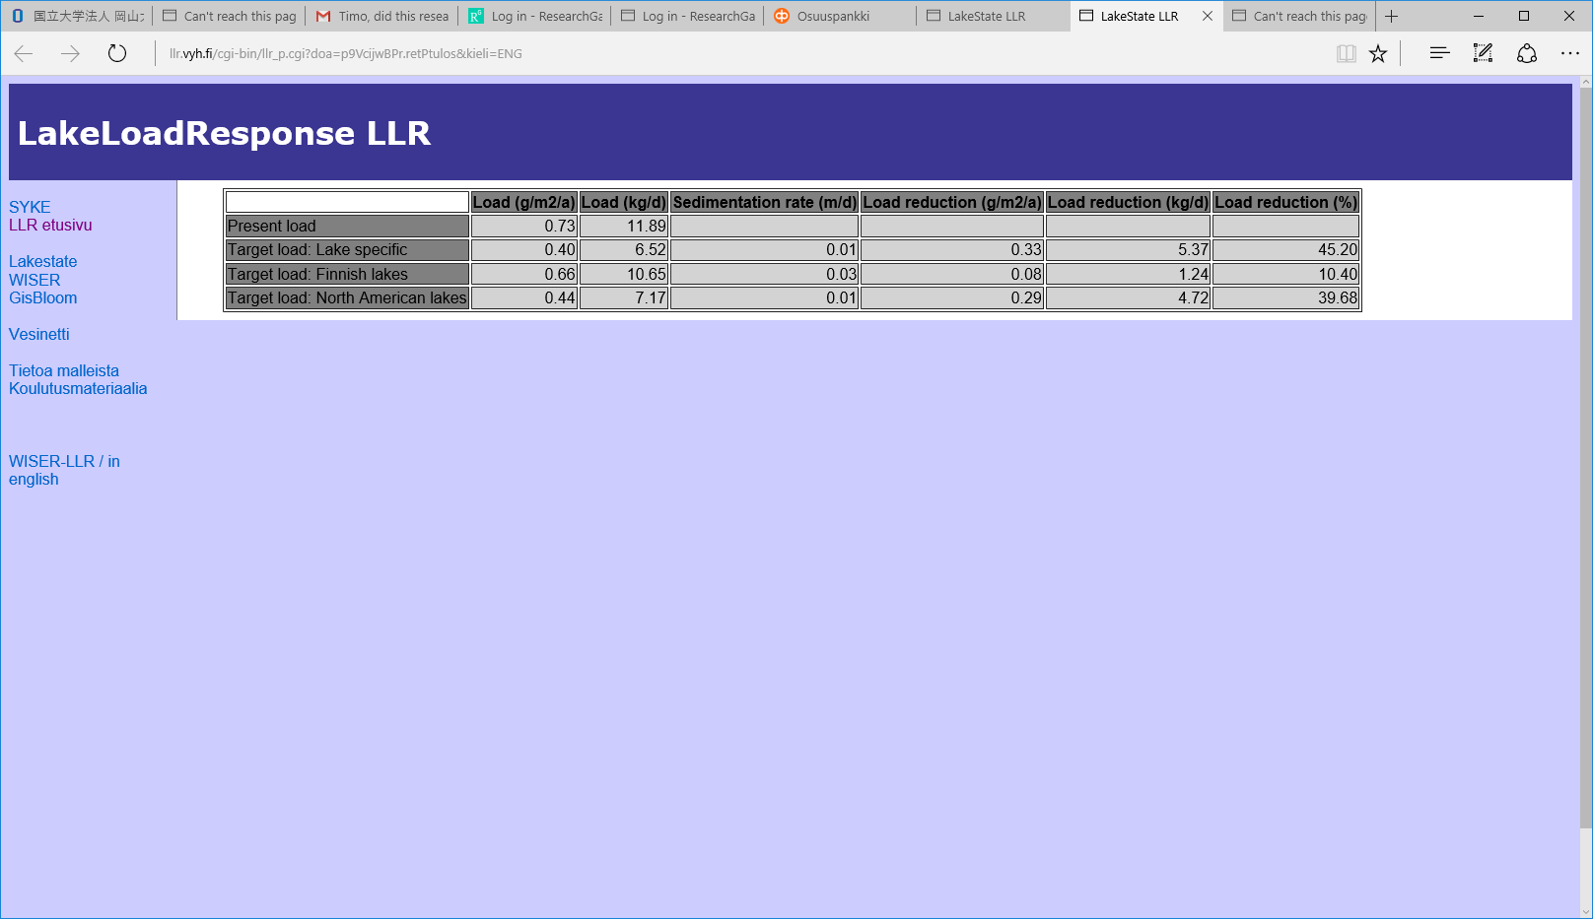

For the interpretation of the results you may LLR-help. Also some help for figure interpretation is given here:

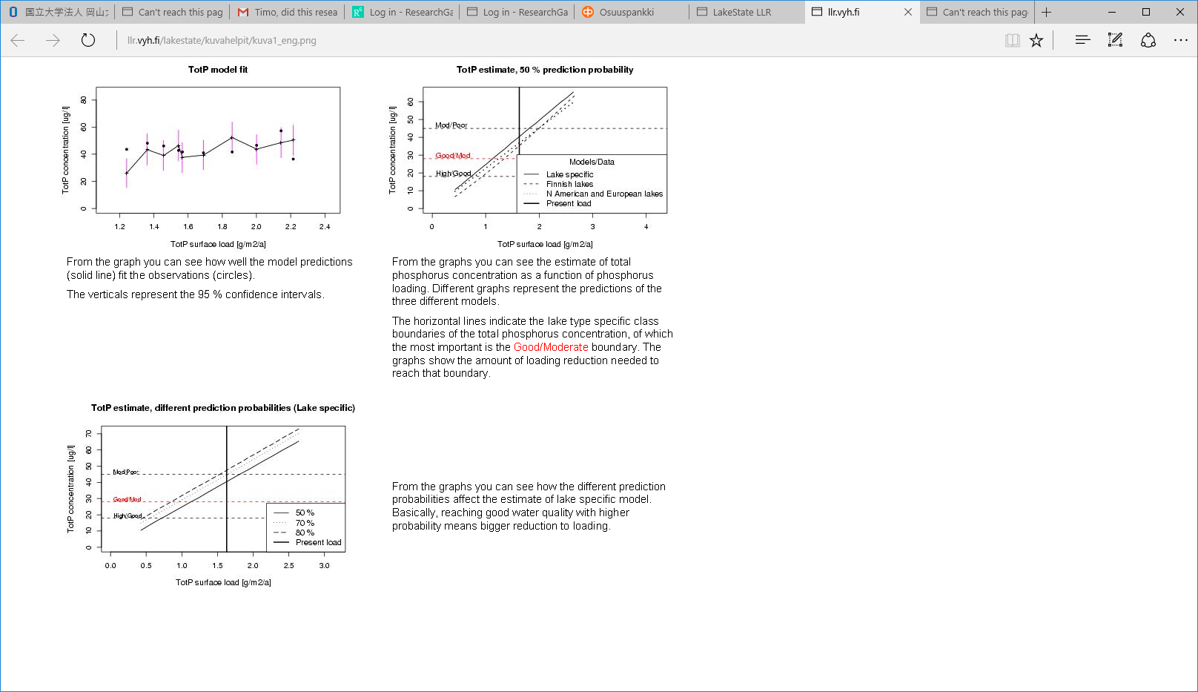

The first results should be studied most carefully in your exercise. So remeber thta we are using a classification for communication of the lake ecological status. Like ’poor, ’ moderate’, good, ’excellent’. The classification is based on the phosphorus, nitrogen and chlophyll-a content. Some other variables are also used, but not in our exercise.

This figure show the P- results of the three models with 50 % probability of the prediction.

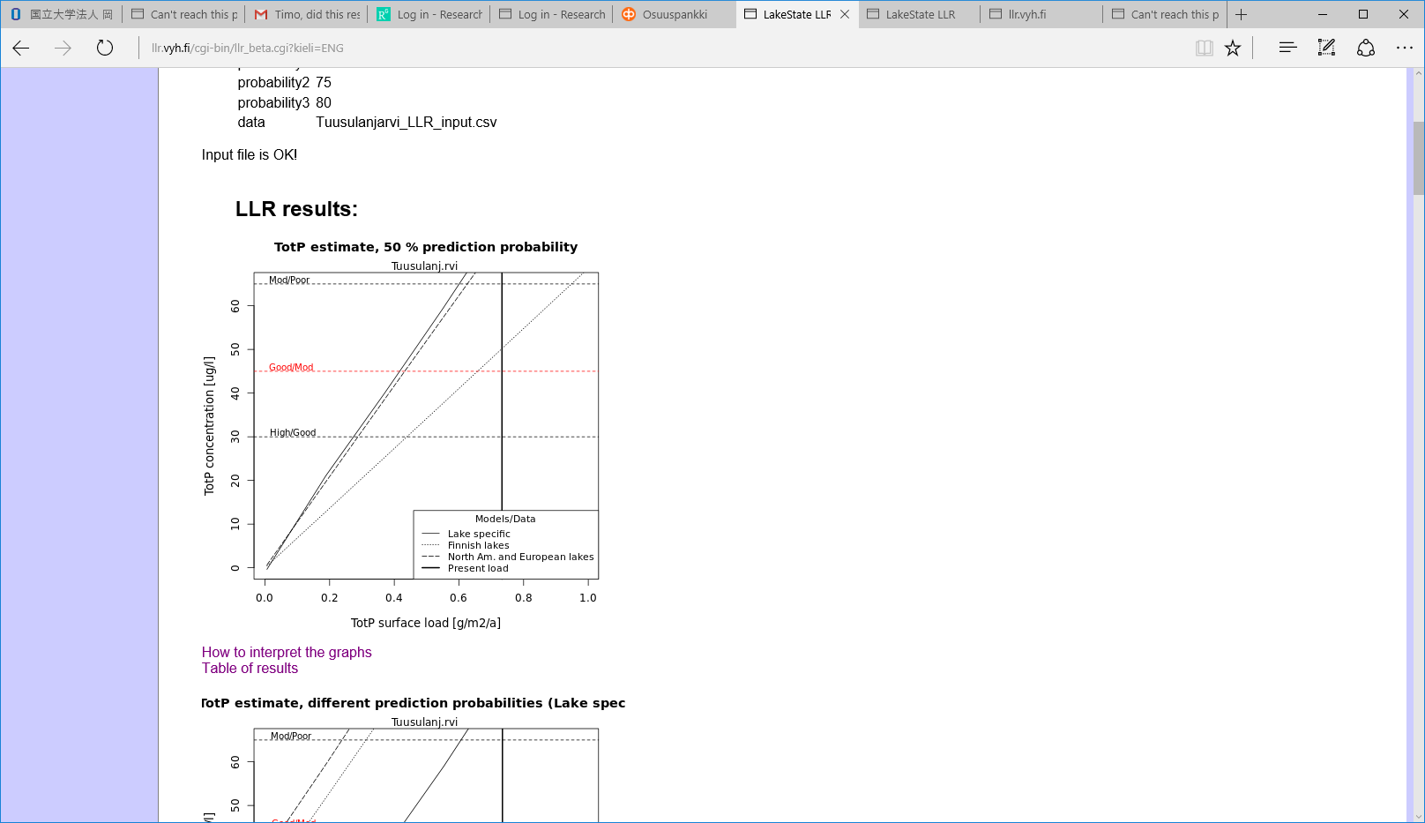

Same for N.

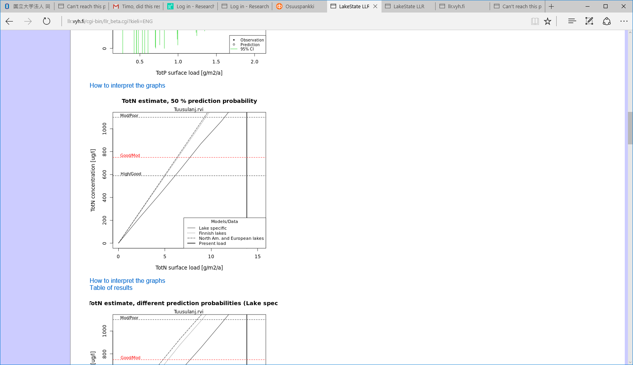

## Questions:

Q1: How does results of the two models (Finnish lake data based and Europe+North America) compare to the lake specific model?

Q2: How much P-load should be reduced in order that the moderate ecological status of the lake is reached? Use 50% prediction probability.

Q3: How much N-load should be reduced in order that the moderate ecological status of the lake is reached?

Use 50% prediction probability.

Also you should look the following two figures and observe the load on different probability levels of lake nutrient concentration calculations:

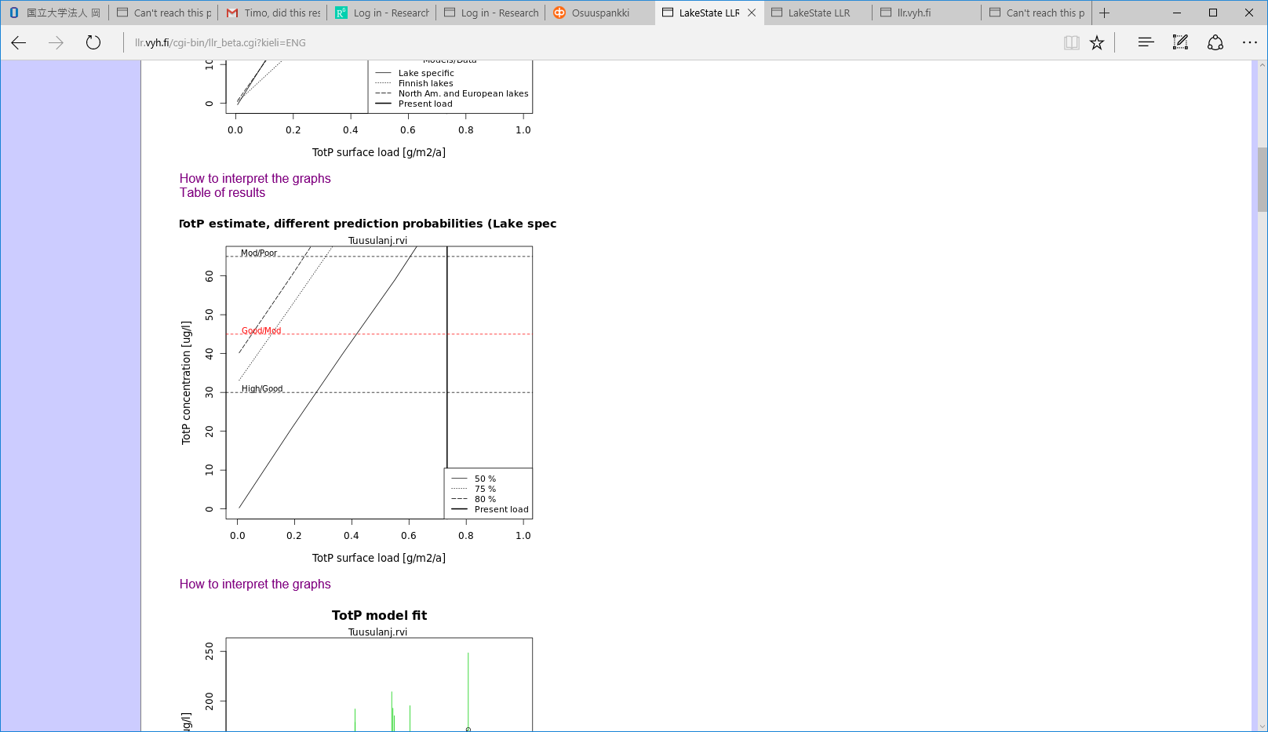

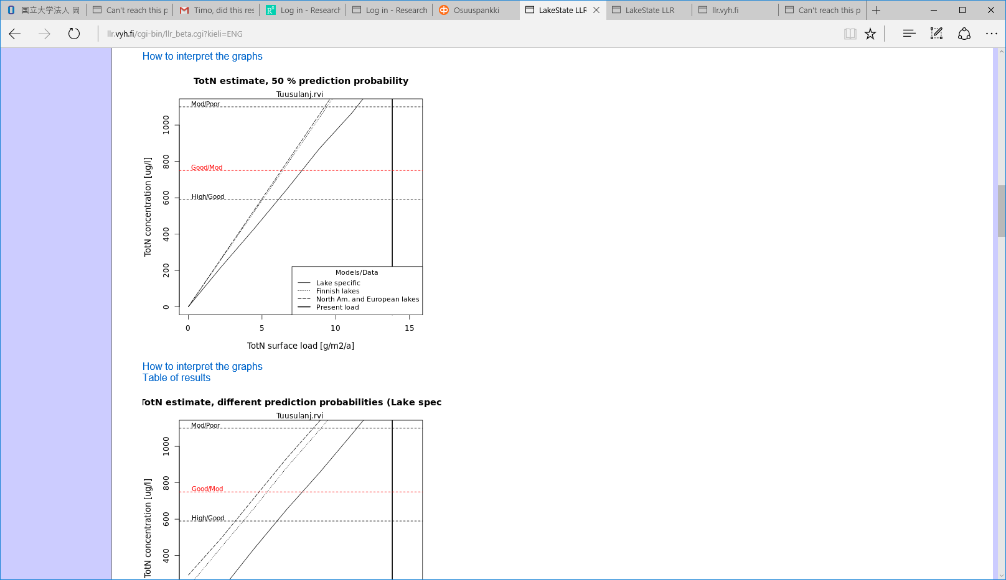

Q4: How much more P-load should be reduced from the 50% probability level in order to reach 75 % probability to obtain moderate ecological status as based on P-concentration in the lake water?

Q5: How much more N-load should be reduced from the 50% probability level in order to reach 75 % probability to obtain moderate ecological status as based on P-concentration in the lake water?

More questions may come later!!